Project Plan
mCon: Rebound multiplayer
  - mCon esports
Rotterdam



Date | 25-05-2025
Version | 0.11
State | Unpublished
Authors | Sander Theeuwen

Contents
Revision History 4
Distribution 4
Introduction 5
Definitions 5
Project Assignment 6
Context 6
Current Situation 6
Current State of the Game 6
Gameplay 6
Implementation 6
Folder Structure 8
Unity Objects 8
Code 8
Desired Updates / Additions 8
Goal of the Project 12
Expandability 13
Assignment 13
Scope 14
Preconditions 14
Strategy 14
Research Questions 14
What is the most suitable way to expand the existing game for multiplayer? 14
End Products 15
Project Organization 17
Stakeholders and Team Members 17
Communication 17
Activities and Time Plan 18
Phases of the Project 18
Testing Strategy and Configuration Management 19
Testing Strategy 19
Test Environment and Required Resources 19
Configuration Management 19
Finances and Risks 20
Project Budget 20
Risk and Mitigation 20
Literature List 21
Attachments 21

Revision History
Version | Date | Authors | Changes | State
0.1 | 06-05-2025 | Sander Theeuwen | Created document.  Added project assignment.  Added project organization.  Added activities and time plan.  Added testing strategy and configuration management.  Added finances and risks. | Unpublished
0.2 | 08-05-2025 | Sander Theeuwen | Added current state of the game.  Expanded document to revised focus on LAN multiplayer rather than connection over Steam.  Added time plan.  Added definitions. | Unpublished
0.3 | 09-05-2025 | Sander Theeuwen | Expanded context.  Expanded current situation.  Expanded current state of the game. | Unpublished
0.4 | 12-05-2025 | Sander Theeuwen | Expanded current state of the game. | Unpublished
0.5 | 13-05-2025 | Sander Theeuwen | Expanded current state of the game.  Expanded goal of the project. | Unpublished
0.6 | 14-05-2025 | Sander Theeuwen | Reworked assignment and current state of the game. | Unpublished
0.7 | 15-05-2025 | Sander Theeuwen | Reworked research questions.  Reworked phases of the project. | Unpublished
0.8 | 16-05-2025 | Sander Theeuwen | Reworked research questions.  Reworked testing strategy. | Unpublished
0.9 | 17-05-2025 | Sander Theeuwen | Reworked project budget.  Reworked risk and mitigation. | Unpublished
0.10 | 18-05-2025 | Sander Theeuwen | Added risks to risk and mitigation.  Reworked style of the document.  Reworked phrasing to better differentiate between current state and the project itself.  Applied feedback from previous developer. | Unpublished
0.11 | 25-05-2025 | Sander Theeuwen | Reworked document to remove other developer as a liability. | Unpublished.

Distribution
Version | Date | Receivers

Introduction
This document contains the necessary information on the company, existing product, and the information needed to start the project. The information on the project includes the assignment, scope, preconditions and strategy, as well as a phased planning of the research, implementation, and testing phase of the project. This document also includes contact information.

Definitions
Term | Definition
Client | mCon esports
Company Mentor | The contact person at mCon, Ruben Been
First Assessor | The primary contact person from Fontys, Michael Schifferling
Developer | The student working on the project, Sander Theeuwen

Project Assignment

Context
The Client is a company based in Grafisch Lyceum Rotterdam that provides tournaments for esports competitors to test their skills, get recognition and status, and more in various games. They have their own space to hold these tournaments with several dozens of spaces for the players. The tournaments include games like League of Legends, Valorant, Rocket League and EA FC 35. Their core team consists of 8 members, there are daily around 35 to 40 employees working, and at events there are 80+ people who help. These events include Heroes Dutch Comic Con, TwitchCon, GameForce, Wish Outdoor, Esports Tour Breda, and Rotterdam Street Culture Week. The Client has their own esports competitive team to participate in events as well.
The Client has created one project before, a simple web game, but mCon: Rebound is the first big project they are working on themselves.

Current Situation
The Client is currently planning on creating an mCon Universe, where there will be characters created by the Client with each one having a background and having intertwined stories. The Client wishes to create a game that has these characters in it to promote their brand and to keep their fans engaged. A game has been created that can support the integration of these characters but is currently using placeholder characters until the mCon Universe is created and is designed for 2 players.

Current State of the Game

Gameplay
Currently mCon: Rebound will work as follows: The players will each select a hero to play as and will step into the ‘start zone’, marked with a color in the playing field. When every player is in the start zone, the game will load a random map, and the players are spawned. The playing field is divided into two halves separated by a wall with each team occupying one half. If there are multiple players in a team, they will be scattered among the team’s half. When the game starts, the players can shoot projectiles at each other or the environment. The environment causes the projectiles to ricochet, causing a bullet hell experience where it requires skill to both dodge the incoming hazards and to overwhelm the opponent(s). Each player’s hero has an ability that can be used as either offense or defense. These abilities vary per hero. When all characters of a team are eliminated, the surviving team wins.

Implementation
The current product is fully playable but only supports same-screen multiplayer. The game’s functionalities excluding the current iteration of the UI are balanced and thoroughly tested at events, including a lobby and several levels as seen in Figures 1 and 2. The models are low poly and have animations like attacks, dodges, and victories.
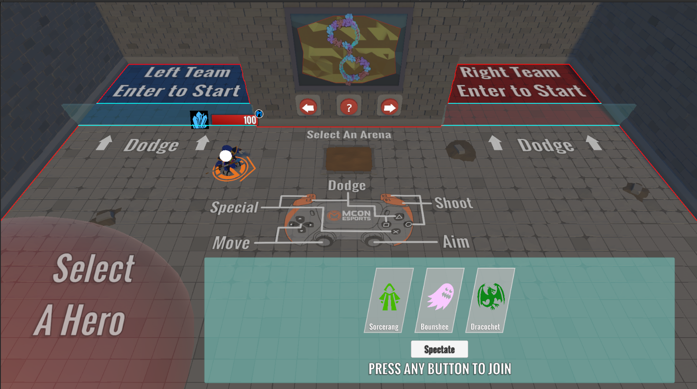
Figure 1 Hero selection
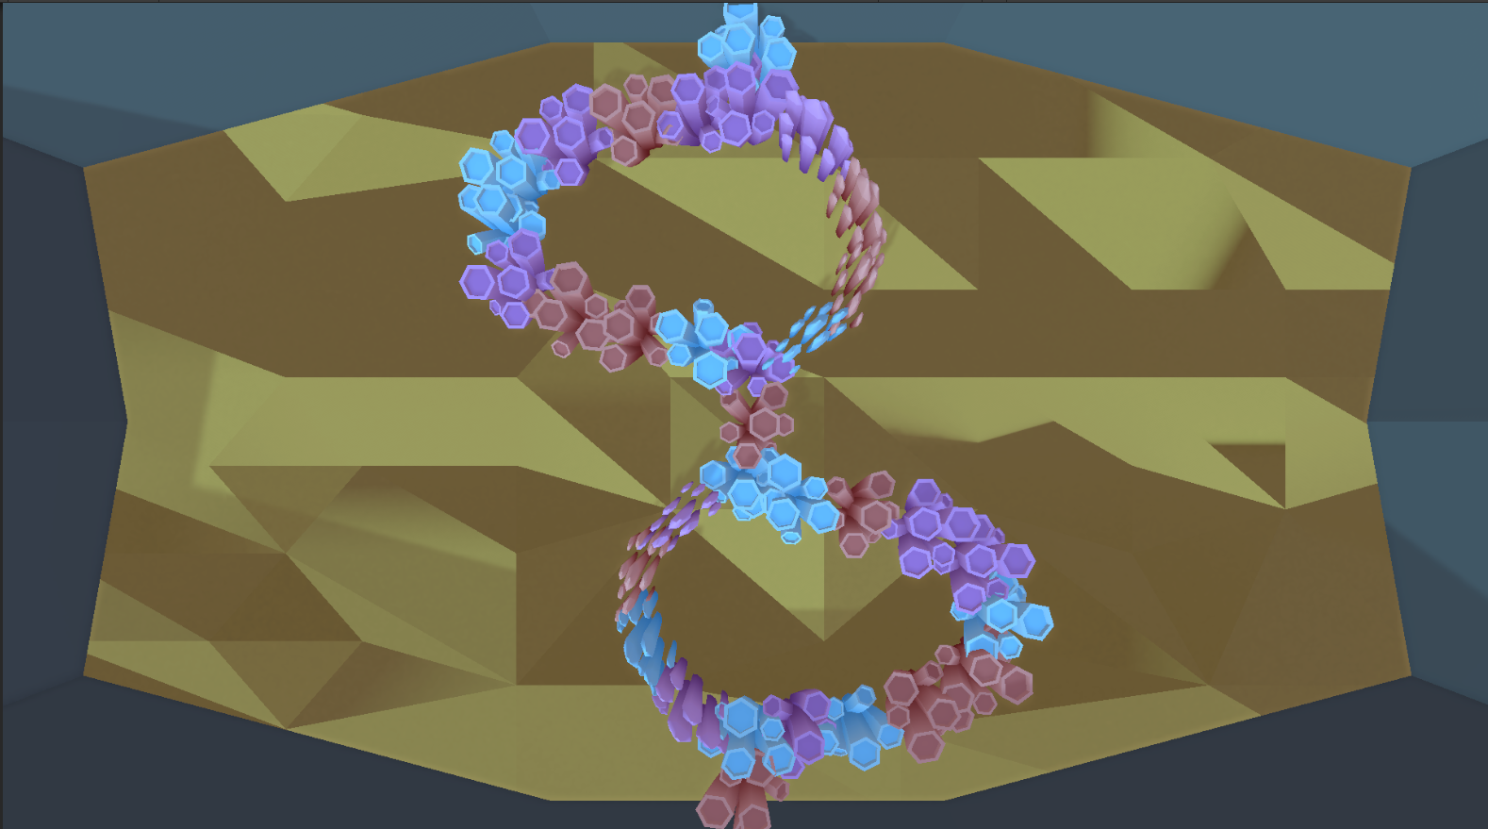
Figure 2 Level "Invasion"
The developer that started mCon: Rebound’s development indicated that the current iteration of the UI has not been tested thoroughly and needs tweaking.
In the table below the completed features are listed, as well as the features that require some work, according to Attachment A, the advice document made by the previous developer with suggestions for further implementation and design.
Finished | Desired updates / additions
Pre-game lobby functionality – selecting a character | Unity scenes - separation of game objects and UI
Pre-game lobby functionality – selecting an arena | Code - separation of Hero script
Pre-game lobby functionality – deselecting a character | Character selection onboarding
Pre-game lobby functionality – selecting the spectator role | Additional heroes
Pre-game lobby functionality – functioning character | Additional arenas
Pre-game lobby functionality – ready zones that start the game | Mana system
Pre-game lobby functionality – walls the players must dodge through | CPU opponents
Arena - objects | Single player campaign
 | Online multiplayer
 | UI overlay pre-game lobby
 | UI overlay arena
 | UI overlay hero
 | Arena “Barricade” – lava texture
 | Arena “Invasion” – floor texture
 | Arena “Invasion” – wall texture
 | Arena “Snow” – floor texture
 | Arena “Spikes” – wall texture
 | Arena “Spikes” – floor texture

Folder Structure
The structure of the current game is easy to understand. The previous developer used clear names and categories that do not make folders cluttered or redundant. The biggest file count in a folder is 11, which is around the limit for the Developer to work with. Should changes be necessary, then these will be easy to make as Unity allows for easy movement of files and folders by editing the file path references in the Editor automatically.

Unity Objects
The game objects used in the scene are well named and put in empty game objects where necessary. One thing to look out for is the combination of in-game objects and UI. This will be separated by the Developer when the implementation phase begins. The highest number of objects within an empty game object lies around 15 and can only be found in the wall objects of the levels, so it does not pose a problem.

Code
The overall code looks easy to understand and avoids God-scripts except for the Hero script, which is separable by function (movement, attacks, input, health). Functions are kept short and have comments to clarify when necessary. The code follows clear naming conventions and separation in the Unity Inspector. The scripts are functional, consistent, easy to understand, and reusable. The previous developer made effective use of inheritance and interfaces with the appropriate naming conventions.

Desired Updates / Additions
The updates / additions listed below are a result of the Advice Document in Attachment A. These features will not necessarily be implemented by the Developer. Refer to the Scope to see what the Developer will work on.

Unity Scenes - Separation of Game Objects and UI
In the current state of the game, the game objects and UI elements are intertwined. The Developer would like to separate them for clarity on where to find certain objects. Especially in the case of UI, it is important to be able to find the elements in a general location rather than spread out over multiple objects.

Code – Separation of Hero Script
The current script called “Hero” functions as a God-script, which can be cluttering, making it difficult to find (and then adjust) certain sections of the script. By the SOLID Single Responsibility principle, it would be best to split this class into separate subclasses.

Character Selection Onboarding
As stated in the Advice Document in Attachment A, the character select scene also functions as an onboarding section. It gives the players time to discover the controls and their character without hostility. However, to start the game, the only movement required is walking and dashing. The previous developer stated it is worth exploring the requirement to perform more actions to start, e.g. shooting or using a special.

Additional Heroes
The previous developer stated in Attachment A, the Advice Document, that players generally expect a lot of content from a game like this, though this claim must be confirmed. If true, additional heroes means more playstyles and complexity to the game. More research must be carried out, but it is worth investigating. The document contains a guide on how to add a hero.

Additional Arenas
Along with additional heroes, the previous developer also states in the Advice Document in Attachment A that there can be more arenas to be implemented into the existing game. As with the additional heroes, it must be confirmed that players expect more arenas from the game. This also has a guide for implementation.

Mana System
In the Advice Document in Attachment A, a mana system is proposed to give the game a layer of agency. The previous developer suggests the creation of mana crystals to restore mana and suggests that actions like shooting projectiles and using specials would use mana. This way, the players are punished for mindlessly attacking and using specials to enforce the use of strategy. As stated by the previous developer, this system would need to be tested heavily, as it introduces a whole new layer of strategy, information, and balance.

CPU Opponents
In the advice for wider release in the Advice Document, Attachment A, CPU opponents are proposed to make the game available for single players. This will contribute to the ability to practice, which is useful for esports games and introductions to esports.

Single Player Campaign
Along with CPU opponents, the Advice Document in Attachment A also suggests a single player campaign to be added. Research must be done to conclude whether this addition is desired by the players and what it should look like.

Online Multiplayer
In Attachment A, the Advice Document, an online multiplayer feature is suggested should the game be released. The method for implementation must be researched, where the impact on the predictability of the dodging mechanic from the game is most important.

UI Overlay Lobby
As the UI in the lobby has not been tested very thoroughly, it will need testing and potentially reiteration in case the test results show it is required.

UI Overlay Arena
Currently, the arenas themselves have no UI aside from the hero UI mentioned later. It could be worth investigating whether this would be a good addition.

UI Overlay Hero
The hero UI has not been tested very thoroughly like the lobby UI. It will need additional tests to see if the current version is most suitable or needs updates.

Arena “Barricade” – Lava Texture
The lava pool in the middle of the arena is currently a simplistic texture, as seen in Figure 3. To match the texture quality of the surrounding objects, it must be replaced.
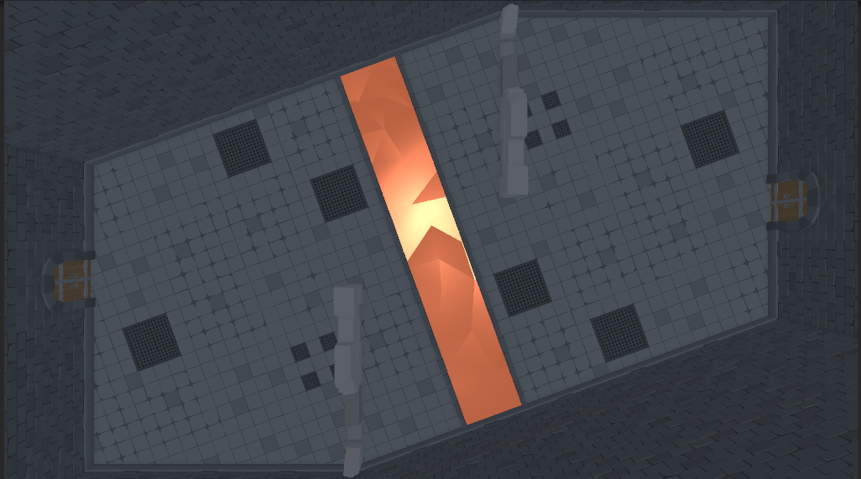
Figure 3 Arena "Barricade"

Arena “Invasion” – Floor Texture
The coral reefs in this arena are of higher quality than the floor, seen in Figure 4. To match this higher quality (as the rest of the game also uses higher quality assets), the floor texture must be replaced.
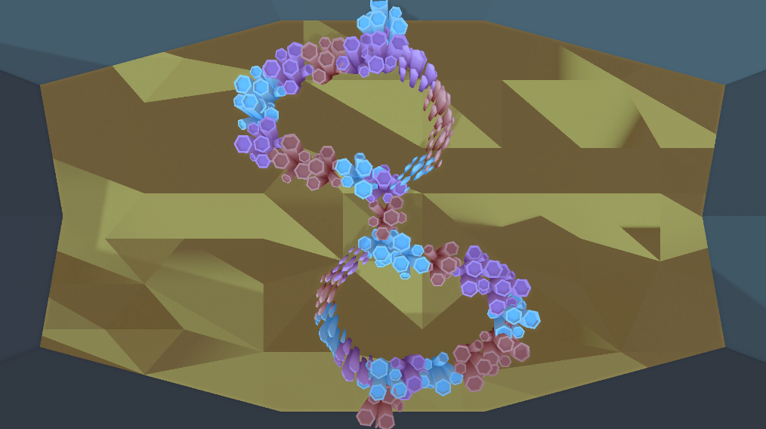
Figure 4 Arena "Invasion"

Arena “Invasion” – Wall Texture
Like the floor texture of this arena, the wall texture, shown in Figure 4, is also of considerably lower quality compared to the rest of the game and must also be replaced.

Arena “Snow” – Floor Texture
The floor texture needs updating to match the rest of the game’s textures. As seen in Figure 5, the floor is of lower quality than the rest of the arena.
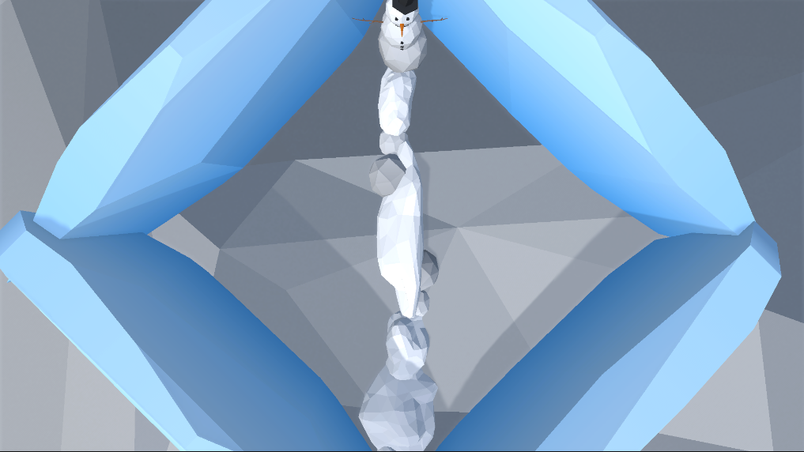
Figure 5 Arena "Snow"

Arena “Spikes” – Wall Texture
The walls in the “Spikes” arena are a solid color and have no variation. This needs to be updated according to the rest of the game’s assets. The arena is shown in Figure 6.
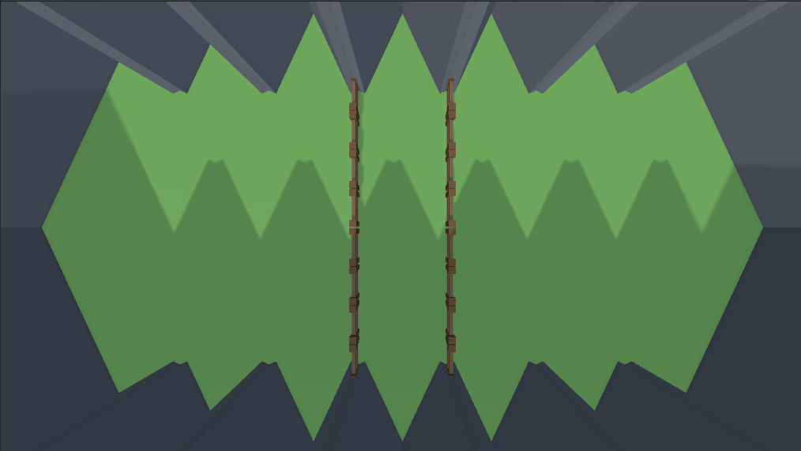
Figure 6 Arena "Spikes"

Arena “Spikes” – Floor Texture
Like the walls, the floor texture of this arena is a solid color, also visible in Figure 6. This must be updated to match other assets of the game.

Goal of the Project
As there is a large gap between casual gaming and esports, the Client aims to narrow this gap, the game can be used at conventions as an introduction to esports. The current game can be used as a short competitive game that allows casual players to experience what it is like to play in a more competitive setting. Should the Client reserve a big space to give the players this opportunity, then the LAN multiplayer feature can be used for this. The Client aims to get many people to get into esports, which includes esports games with many players like Apex Legends (ALGS Year 5 | Official Homepage | Apex Legends Global Series, n.d.), so mCon: Rebound’s LAN multiplayer feature could introduce players in bigger lobbies.
To give the fans a valuable connection with the Client, the Client decided to create their own game rather than simply using an existing game. Instead of being connected through events where players play already existing games, it essentially cuts out the middleman by playing a game owned by the Client themselves. An existing game cannot do this as it creates connection towards the brand of the game, not the Client. Additionally, to support the branding there is currently an mCon universe in creation that will eventually be added to the game that will additionally build the community larger by playing the Client’s game together and getting friends to play the game with them.
The game was created by Kayleigh Westerweele, a graduate student from Fontys, who delivered a playable game that is designed for 2 players but has spawn locations for 6. The goal of the project is to expand this multiplayer feature to support many more players, as the Client has space for around 50 players.
In the desired situation, the Client can set up the game on LAN and the players can join using the PCs at the esports space in the same room. Therefore, this game is designed to be played at the Client’s location, publicly accessible through their events.
The project’s unique selling points are simplicity with a challenge: The core components of the game are easy to understand, while the skill ceiling is high with dynamics like understanding the hitboxes and ricochet directions of the environment, the timing and direction of shooting projectiles and using specials. With the multiplayer feature, the high skill ceiling can keep players interested in the game, as it is shown in multiple competitive games (or games that allow competitive play) like Fortnite, Dead by Daylight, and Rocket League that players enjoy skill expression which keeps them engaged. New players that are introduced to esports can also use the multiplayer feature as it lets them experience how playing in an esports setting is with a big player pool.
The product contains the colors of the Client’s brand to promote the company in terms of branding.
In its current state, the product has enough content to be considered complete. The features are complete for its current state and aside from the UI have been tested and balanced thoroughly. It should be noted that the textures require an update for the game to be visually more complete.

Expandability
Using the guides from the Advice Document in Attachment A, to create additional heroes and arenas, the current game supports expandability in terms of content. To make the game support more players, the target being 50 as the Client’s location contains this number of stations, the design requires some reiteration: it should be researched what the most suitable way is to expand the game to 50-multiplayer, for example a bracket system or a battle royale. This will determine if the design requires updates as well.
To make the multiplayer feature, it was indicated by former classmates of the Developer that code fundamentally needs updates as well, specifically position values from heroes and projectiles, as well as the game state. Predictably, once it is researched what the best method is for one component, it can be reused for the rest.

Assignment
The assignment of this project is solely to design and implement support multiplayer over LAN, with the target of 50 players as supported by the esports area. The project includes research further described in Research questions and the implementation of the multiplayer feature, which entails a lobby system, the setup of connection between PCs over LAN, and minor adjustments in the current game to support all the players.
The modification of the core gameplay of the current state of the game can be done on the condition that it will only require minor changes, for example making arenas bigger, changing the onboarding scene to support a lobby system. Should major changes be deemed necessary by research done on the multiplayer aspect, this will be listed in the advice document that is created during the project’s development.
The design challenge for the game is as follows:
Extend (by designing and implementing / modifying) the medium fidelity same-screen multiplayer game to support multiplayer over LAN for players aged 10 to 50 that attend events like Heroes Dutch Comic Con and TwitchCon that the Client wants to introduce to esports to let the players experience an esports environment at the Client’s location, so the players encouraged to go to more of the Client’s tournaments / events.

Scope
Must | Should | Could | Will not
Project plan | Unity scenes – separation of game objects | Character selection onboarding | Additional character creation
Game design document | Code – separation of Hero script | CPU opponents | Models and textures
Test report |  | UI overlay lobby | Connection through Steam
Research document |  | UI overlay arena | Additional heroes
Lobby system that supports 50 players |  | UI overlay hero | Additional arenas
Connection through LAN |  |  | Mana system
Advice document |  |  | Single player campaign
User stories document |  |  | Online multiplayer
Meeting log
Portfolio
Decision document

Preconditions
The project will be developed in Unity using C#. This is because the existing game also uses this technology.
The existing low fidelity game is fully functional but requires some polishing mainly in the UI and textures as mentioned in Desired updates / additions, which will be done by Kayleigh Westerweele.

Strategy
The project will be developed using the Scrum agile approach because the LAN multiplayer feature is suspected to require many iterations, which is best done in quick succession as tests can be performed quicker as opposed by fully finishing and polishing an iteration before testing. More importantly, with an agile approach, the test results can be implemented immediately in the next iteration. At the start of the project, extensive research will be done to decide the best way for implementing multiplayer while small changes are being made according to the table in Scope. When this decision is made, the multiplayer feature will be implemented and tested in an iterative approach, ensuring quality and validation of functionality. As the multiplayer feature is added, the project will be polished according to the client’s needs.

Research Questions

What is the most suitable way to expand the existing game for multiplayer?

What are the requirements in the design of the existing game to be able to expand to 50-multiplayer?
Stakeholder analyses can be used for the players to figure out what they would want from the current state of the game to be multiplayer, for example a bracket system or a battle royale. This can be tested using paper prototypes by writing down a bracket system on a note while using the existing product to determine the player’s positions.
To then figure out what is important for games to support multiplayer from a technical standpoint, I can use available product analysis. This will tell me what common bottlenecks are, like matchmaking (including the time required to find a match while keeping matchmaking fair) or a requirement of high ping in fast paced games.

What existing multiplayer frameworks that meet the requirements are there?
I will start by using literature study combined with available product analysis to search for myself what options are out there and how they work to get a small overview of the most popular frameworks.
I will then use expert interviews with former classmates who worked on multiplayer projects before, asking what their experience was to discover pros and cons of specific technologies so I can decide on what to use for this project.

Which of the multiplayer frameworks that meet the requirements are suitable for the game?

If multiple frameworks are suitable for the game, would it be possible, viable, and in the best interest to combine these options?
Primarily, I will investigate good and bad practices to figure out whether it is viable to combine frameworks. This will also heavily depend on literature study, as it is more of a technical question whether it is even possible and efficient to combine multiple options. I can use community research to discover if developers did this before and whether it is good practice. This also depends on the budget of the Client, as the multiplayer frameworks can cost money.

If multiple frameworks are suitable, but not possible or viable to combine, which option is most suitable for the game?
I will perform a product analysis to see the potential bottlenecks of the game, then based on stakeholder analysis where I will learn what the most important aspects of the multiplayer functionality are (like latency, thoroughness, etc.) I will decide on what would be most suitable. If need be, I can use literature study or community research to support in making this decision.

How can the most suitable multiplayer option be implemented in the game in Unity?
I will start by using expert interviews by interviewing people who have already worked with the multiplayer option to discover the best approach on implementation. I can also use literature study and community research to learn. To ensure the quality of the implementation, I will use peer reviews to get tips on how to optimize my code. I will also perform static program analysis, suspectedly by using the debug mode in the editor, to see how efficient the code is and to spot and fix / mitigate potential bottlenecks.

End Products
mCon: Rebound multiplayer expansion:
The game that supports 50-multiplayer over LAN.
Game design document:
The document where all details concerning design and mechanics of the game are listed and elaborated.
Test report:
A compilation of the tests and the results, how and when the tests were performed and what was tested.
Research document:
The research that will be done during the development of the project.
Project plan:
This document contains details about the assignment.
Advice document:
A document containing advice about future development, consisting of miscellaneous research and recommendations.
User stories document:
A document consisting of user stories that will be used for the designing of the features.
Meeting log:
A set of documents that hold notes from meetings.
Portfolio:
A collection consisting of devlogs and products that serve both as proof of the work and the reasoning and decision making behind the project’s features / challenges.
Decision document:
A document containing a summary of the decisions made in the project with a short reasoning, shorter than the portfolio and made for distribution.

Project Organization

Stakeholders and Team Members
Name | Abbreviation | Role and functions | Availability
Sander Theeuwen  s.theeuwen@student.fontys.nl  +31 6 10433821 |  | Scrum master.  Developer.  Product owner. | Monday: 9.00  17.00  Tuesday: 9.00  17.00  Wednesday: 9.00  17.00  Thursday: 9.00  17.00  Friday: 9.00  17.00  Saturday: -  Sunday: -
Ruben Been  ruben@mconesports.com  +31 6 51703950 |  | Client’s representative.  Company mentor. | Contact through MS Teams
Kayleigh Westerweele |  | Developer. | Contact through Discord.
Michael Schifferlinng  m.schifferling@fontys.nl  +31 885086625 |  | Primary Fontys contact.  Assessor 1.  Semester coach. | Contact through email or MS Teams
End-users |  | Target group | -
People working on the mCon universe |  | mCon universe creators. | Contact through the Client.

Target group:
Players aged 10 to 50 that attend events like Heroes Dutch Comic Con and TwitchCon that the Client wants to introduce to esports.

Communication
For periodic feedback meetings, I can contact the Company Mentor through WhatsApp or email. I will be using email as it is more professional. These requests for meetings will be sent long in advance. The project aims to have update meetings around every 3 weeks to make sure the client/company mentor is up to date.
MS Teams will be the means of communication with the Fontys assessors.
There will be several meetings with an assessor about the portfolio to make sure it is up to the standards required by Fontys. Halfway through the semester there will be a preliminary assessment of the portfolio.
Contact with the previous developer will be done through Discord for efficiency.

Activities and Time Plan

Phases of the Project
Project setup – 1 week:
This week will be around setting up the environment and organizational necessities like project planning, meeting organization (frequency / topics) and preparation for development.
Research – 4 weeks:
This phase will be focused on the research of the multiplayer feature to ensure the most suitable implementation and design is guaranteed. In the meantime, small updates to the project from the Scope will be implemented.
First implementation, MVP – 3 weeks:
The multiplayer feature will be implemented into the existing game, this will be the minimal viable product.
Testing and further refinements, 6 weeks:
The product will be tested continuously and reiteratively improved upon.
Polishing – 3 weeks:
Some final changes to polish the product.
Finalization – 1 week:
The project will be prepared for delivery, and the end presentation will be made.
Phasing | Effort | Time
Project setup |  | Week 1-4
Research |  | Week 5 – 8
First implementation |  | Week 9 – 11
Testing and further refinements |  | Week 12 – 14
Polishing |  | Week 15 – 17
Finalization |  | Week 18
After every phase, a retrospective is held to improve efficiency for the upcoming phases.

Testing Strategy and Configuration Management

Testing Strategy
The technical aspects of the 50-multiplayer feature will be tested using code reviews combined with expert interviews to guarantee the efficiency of the code. This will be tested further using data analysis using the stations at the Client’s location, ideally all 50 of them. The results will be iterated on determined by requirement prioritization.
The user satisfaction testing mainly consists of observations and surveys to gather feedback from larger groups, while interviews and focus groups will be used to finetune the product during development. This will mainly be done to see if players are content with the feature to discover potential bottlenecks that were unseen before.

Test Environment and Required Resources
Paper prototypes can be used with friends and family to get an idea of the effectiveness of the functionality of it. Next, esports players will be consulted to try out the paper prototypes to guarantee they are up to the standards of esports. This can be done through friends that participate in esports and at conventions like TwitchCon or Heroes Dutch Comic Con. The game will be tested using the developer’s computer and potentially old classmates of the Developer or employees of the Client in the prototyping stage to make a functioning prototype. When the code is working on 2 computers and it is deemed ready for elaborate testing by the experts, it will be tested at the Client’s location on more computers to gather data on performance and functionality, which then will be discussed with experts to improve the game / prototypes.

Configuration Management
The tool used for version control will be GitHub, as it is an industry standard and the project is not owned by Fontys itself. In the repository, a “main” branch will be used for deployments and will, together with the “develop” branch, have the latest updates. For every feature or standalone component, a new branch will be created from the “develop” branch and deleted when finished. Hotfixes will have their own branch, also branching from the “develop” branch.

Finances and Risks

Project Budget
The project does not have a set budget. All choices that lead to purchases will be thoroughly documented and then proposed to the client for review. The final decision for purchases will be made by the company mentor.

Risk and Mitigation
Risk | Prevention activities | Mitigation activities
The company is unable to assist in game design / technical problems due to lack of experience. | - | Former classmates of the Developer can be consulted. Teachers at Fontys can also be consulted if necessary.
The other developer stops working on the project. | - | There no expectations from the other developer to remove her as a liability. Necessary updates in the project are done by the Developer.
Players are not interested in the 50-multiplayer game. | - | -
The Company Mentor is unavailable for an extended period. | - | The First Assessor will be informed. The project will continue to be developed.
The Developer is unavailable for an extended period. | - | The Company Mentor and First Assessor will be informed immediately, and the situation will be discussed.
Project gets terminated. | Ask for periodic feedback. | A different project can be started or resumed by the Developer.
Git is unavailable. | - | The Company Mentor will be informed. The project is continued locally where different versions are saved in different locations.
Extended internet outage. | - | The Developer will solely work on location.
Assessors judge the project to have insufficient complexity. | - | A meeting will be held with the Company Mentor, the Developer, and the First Assessor to expand the project, so it has enough complexity.
Assessors decide the developer will not pass the semester. | Ask for feedback periodically. | The project will continue until the end of the semester.

Literature List
ALGS Year 5 | Official Homepage | Apex Legends Global Series. (n.d.). Retrieved May 13, 2025, from https://algs.ea.com/en

Attachments
Attachment A – Advice document
This document is made by Kayleigh Westerweele, the developer who started the project, in which she makes suggestions for further development concerning implementation, design, and testing.

